EXPERIMENT-: 6

IDR AND NIGHTLAMP

DIAGRAM: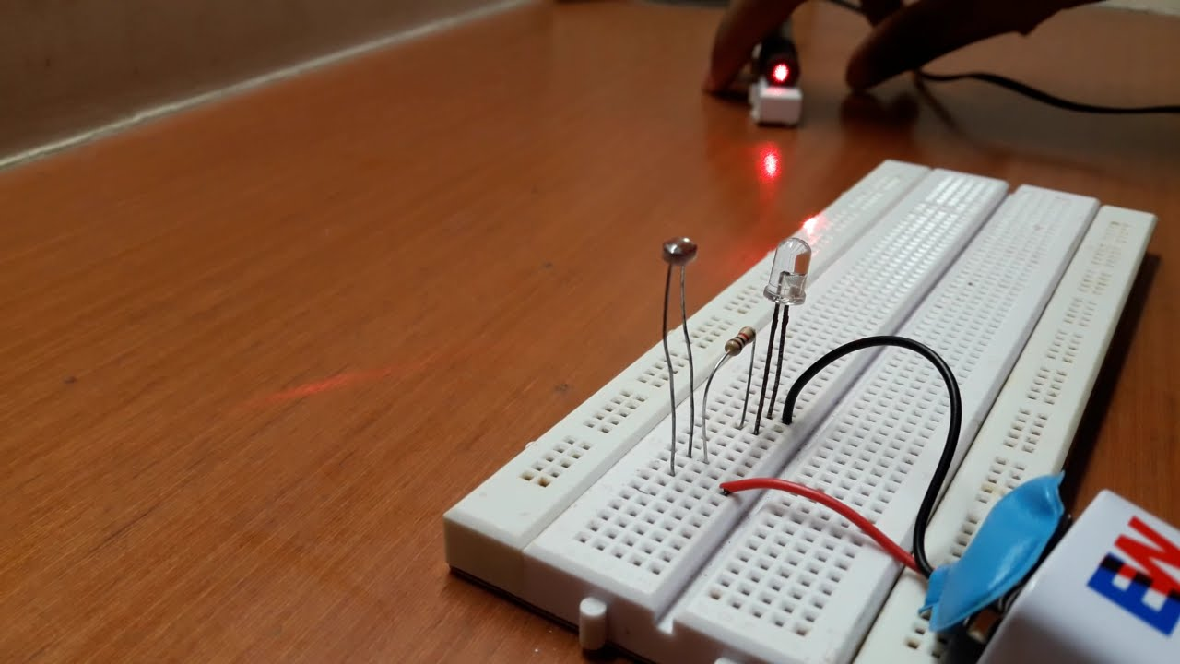

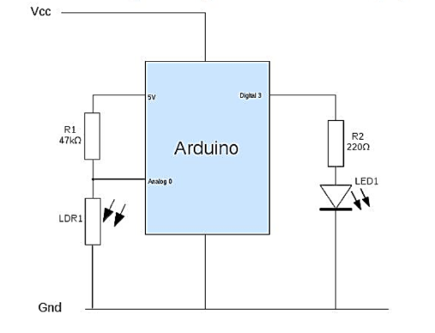

# Theory:-

## Concept used:-

## IDR : Its full form is light dependent resistance.

The resistance of a LDR decreases with increasing incident light intensity.

ADC (ANALOG TO DIGITAL CONVERTER)

An analog-to-digital converter is a system that converts an analog signal, such as a sound picked up by a microphone or light entering a digital camera, into a digital signal.

The voltage resolution of an ADC is equal to its overall voltage measurement range divided by the number of intervals:

where M is the ADC's resolution in bits and EFSR is the full scale

voltage range (also called 'span').

* + Learning and Observation:-Leanings: *I have learned about how to make a series circuit using an arduino board a*

breadboard.

* + *I have learned about how an arduino works and I also learned how current flows and how it works.*
  + *I have now gained a practical experience of how an LED and a resistor work.*
  + *I have also learned the working of a switch.*
  + *I have also learned the use of LDR and how it measures the light sensitivity.*

## Observations:-

* *When we press the switch the automated system turns on.*
* *Then when the light intensity is increased above 300 lux,the led glows with 50% brightness and when it is below 300 lux the led brightness is 100%.*

# Problems andTroubleshooting:-

The problems faced by me while doing this task are:-

* *The code was not working properly at first so I have to change it many times.*
* *The bulb brightness was not getting increased so I have to change the connections.*
* *At first I was not able to know the device we have to use to calculate light intensity*

# Precautions:-

The precautions that we need to keep in mind while doing this experiment are:-

* *The connect ion sat different points should not be loose and the pins should be inserted properly.*
* *The two pins of the LED should be connected at their appropriate point that is the positive point should be connected with the p pin and the negative point should be connected with the negative pin.*
* *We should take care that the circuit is closed.*
* *While writing the code extra care should be taken while writing the syntax keeping in mind about different small and a capital words in them.*

# Problems andTroubleshooting:-

***LERANING OUTCOMES:***

* *I have learned how to make circuits using an arduino board and a bread board and some other hardwares.*
* *Through this experiment I have gained the skill of making a circuit using different hardwares and controlling the functions done by that*

circuit with the help of codes. And how to ldr in night lamp.